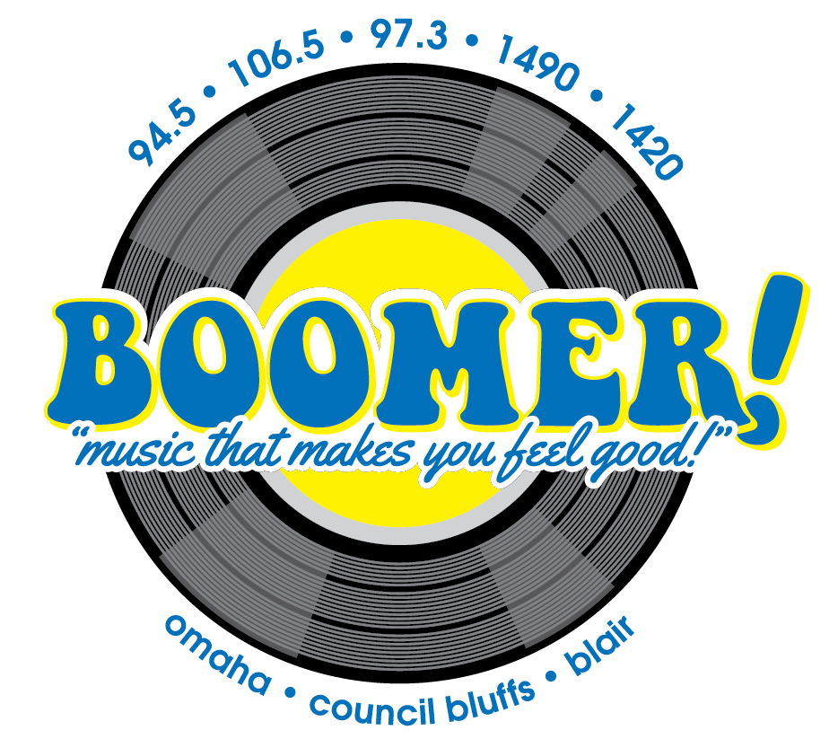
News Sponsorship
Now you can help bring the latest news to our listeners with this news sponsorship package. Newscasts are broadcast in morning and & afternoon drive times.
As a sponsor you receive one sponsorship per day Monday – Friday, including:
- live opening billboard
- :30 commercial following the newscast
Your investment:
97.3 Blair only $150 per week
94.5/ 1420 Omaha only $150 per week
106.5/ 1490 Council Bluffs only $150 per week
Full Boomer Network $300 per week

(Pick your station, 13 week minimum)

____________________________________ _______________
Advertiser Date

