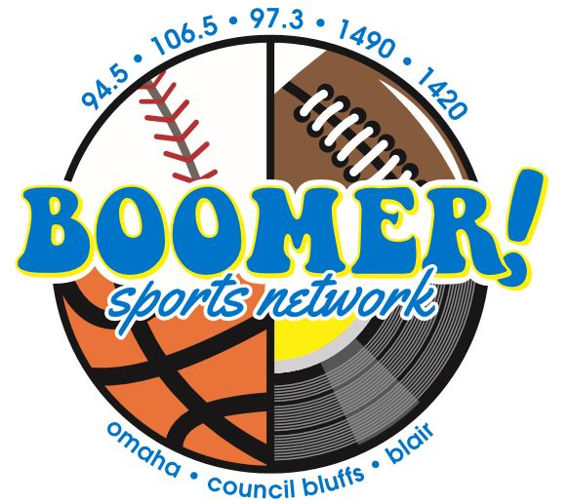

Boomer Sports Network Daily Update Sponsorship
Your business will receive 20 recorded promos each week!
:10 intro liner
:30 commercial adjacency
Boomer Sportscaster Tom Seline highlights the week in sports and upcoming contests 2X per day on the Boomer Radio Network (10:30am/2:30PM M-F)
Investment
$300 per week ($600 value)

Client________________________ Date___________________
Approval_____________________________________________
Boomer Account Executive____________________________

13 week minimum agreement

