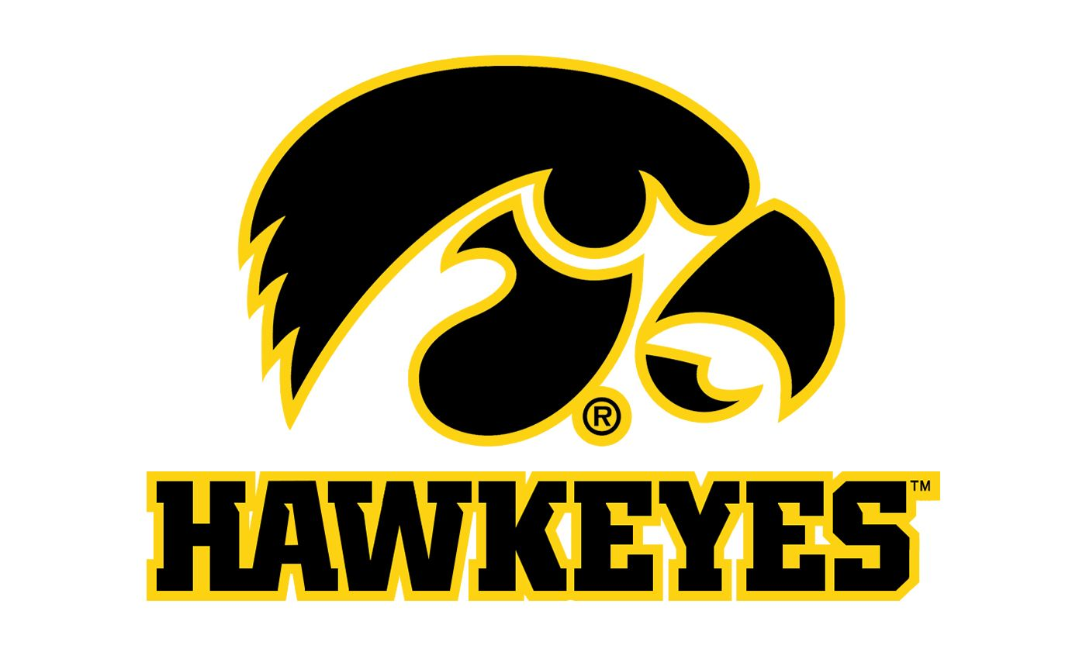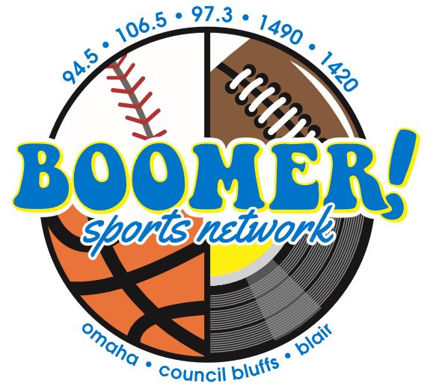

The Hawkeyes on Boomer!

106.5 FM & 1490 AM Omaha

Sponsorship Package

As a Boomer/Hawkeyes sponsor you will receive:
- 4 :30s in each regular season football and basketball game broadcast
- Inclusion in a minimum of 20 promotional announcements each week of the season.
- Hawkeye sponsor Logo on myboomerradio.com

Optional:
- A bank of 30 :30 commercial announcements per month on the Boomer Network (6a-8p M-Sun)

Investment: $450 per month Add on Option $ 400
Billed monthly (August-March) for 2020 season

Yes, count me in!
Business Name: _________________ By: ______________Date_____
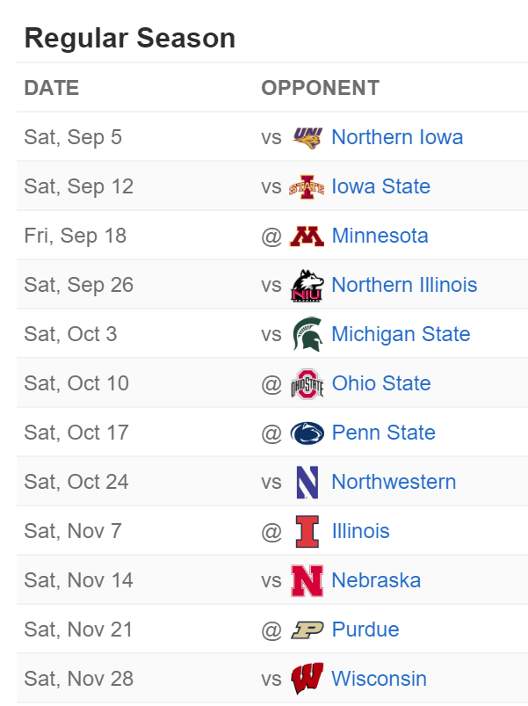
Basketball Non-Conference Schedule:
11/4 - Lindsey Wilson College (Ex.)
11/8 - SIUE
11/11 - DePaul
11/15 - Oral Roberts
11/21 - North Florida
11/14 - Cal Poly
11/28 - Texas Tech (Las Vegas, NV)
11/29 - Creighton/San Diego State (Las Vegas, NV)
12/3 - at Syracuse
12/12 - at Iowa State
12/21 - Cincinnati (Chicago, IL)
12/29 - Kennesaw State
Basketball Conference Schedule:
12/6 - at Michigan
12/9 - Minnesota
1/4 - Penn State (Philadelphia, PA)
1/7 - at Nebraska
1/10 - Maryland
1/14 - at Northwestern
1/17 - Michigan
1/22 - Rutgers
1/27 - Wisconsin
1/30 - at Maryland
2/2 - Illinois
2/5 - at Purdue
2/8 - Nebraska
2/13 - at Indiana
2/16 - at Minnesota
2/20 - Ohio State
2/25 - at Michigan State
2/29 - Penn State
3/3 - Purdue
3/8 - at Illinois

